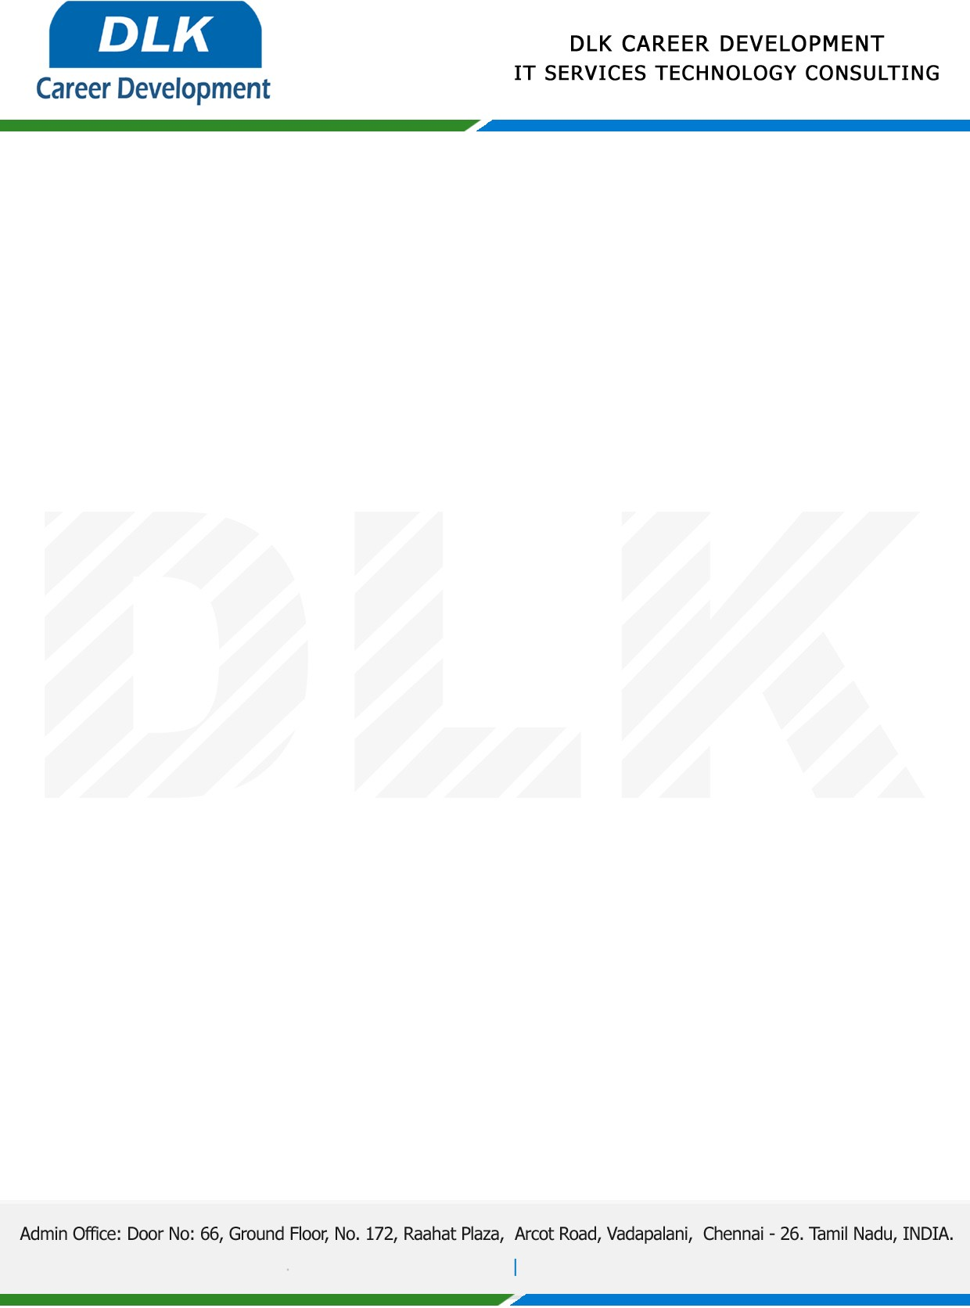

Date: 09/ January / 2023

**To**

Department of BCA ( [Computer Application),](https://www.cseindia.org/)

Head of Department,

Alpha arts and science college, Chennai - 600116.

**Sub: Letter of Project Acceptance**

This is to certify that final year students of has accepted the Project Work duration from **10th** **January 2023** to **15th March 2023** under the domain **“Java”.** During the Project, all information and data collected from you should be kept confidential.

**Team Members:**

1. MS JAYASHREE S(REG NO: 212002805)
2. MS BOOJA J (REG NO: 212002801)
3. MS NANDHINI G (REG NO: 212002810)

**Topic:** Smart Health Prediction and Drug Recommendation Using Data Mining.

We appreciate your interest in **DLK CAREER DEVELOPMENT**

